

South East Coastal
Communities Programme

HEFCE funded
2008 – 2011

June 2008

Hub and Spoke Model

Dianne Sherlock
South East Coastal Communities
Development Manager

LifeMusic Method

Dr Rod Paton
Senior Music Lecturer Community Music

Training Older People as Researchers

Dr Heather Clark
Reader in Social Gerontology

Contents

Index

Hub and Spoke Model Page 5
Introduction 6
Infrastructure and relationships 6
Research and evaluation 7
Success criteria 8
Evaluation approach 9
Milestones and tasks 10
The meaning of ‘community engagement’ 11
Hub and Spoke relationships 11
Ten Community Engagement standard indicators 11
University of Chichester and Community Partners’ work ethic and approach 12
The ‘Voice’ of our Community Engagement Partners 12
Imagine 13
Bibliography 13

LifeMusic Method: Summary Page 14
Activity 15
Background 15
How the proposed activity addresses health and wellbeing:
Philosophy of the programme 16
Aims of the programme 16
Options appraisal 16
Risk - identification and management 16
Sustainability 17
How the proposed activity will be mutually beneficial and will use University resources 17
Anticipated outputs: Objectives of the programme 17
Projected future developments 17
Suggested evaluation approach: Training outline 17
Research 18
Milestones and tasks 19
SECC Budget 20

Training Older People as Researchers: Summary Page 21
Activity 22
Background 22
How the proposed activity addresses health and wellbeing:
Philosophy of the programme 23
Aims of the programme 23
Risk - identification and management 23
Sustainability 23
How the proposed activity will be mutually beneficial and will use University resources 23
Anticipated outputs: Objectives of the programme 24
Suggested evaluation approach: Training outline 24
Evaluation 25
Milestones 26
Tasks 27
SECC Budget 28

Notes Page 29



Hub and Spoke Model

Dianne Sherlock
South East Coastal Communities Development Manager

5
Dianne Sherlock

Knowledge Exchange

University of Chichester: South East Coastal Communities (SECC) Project

Hub and Spoke Model - Introduction
There are well established networks for community engagement in existence in West Sussex and the University of Chichester is firmly represented across a range of organisations and agencies.

Included in both SECC projects would be equality and diversity training supporting the delivery of activities through the University’s successful Human Resources Staff Development Programme.

The University of Chichester is the only university in West Sussex and is well connected to community groups and schools. This distinctive approach could impact on and enrich the lives of an extended number of individuals in the community who would be able to share and pass on their learning to further individuals and community members.

The University will develop a hub and spoke model of community activity, communication and funding both actual (where possible) and in kind which will enable, develop and ultimately sustain Higher Education Institution (HEI) / community engagement across the West Sussex south east coastal region, leading to further collaboration and sharing of outcomes across the county to our partner HEIs, acting as a demonstrator to other regions.

Infrastructure and Relationships

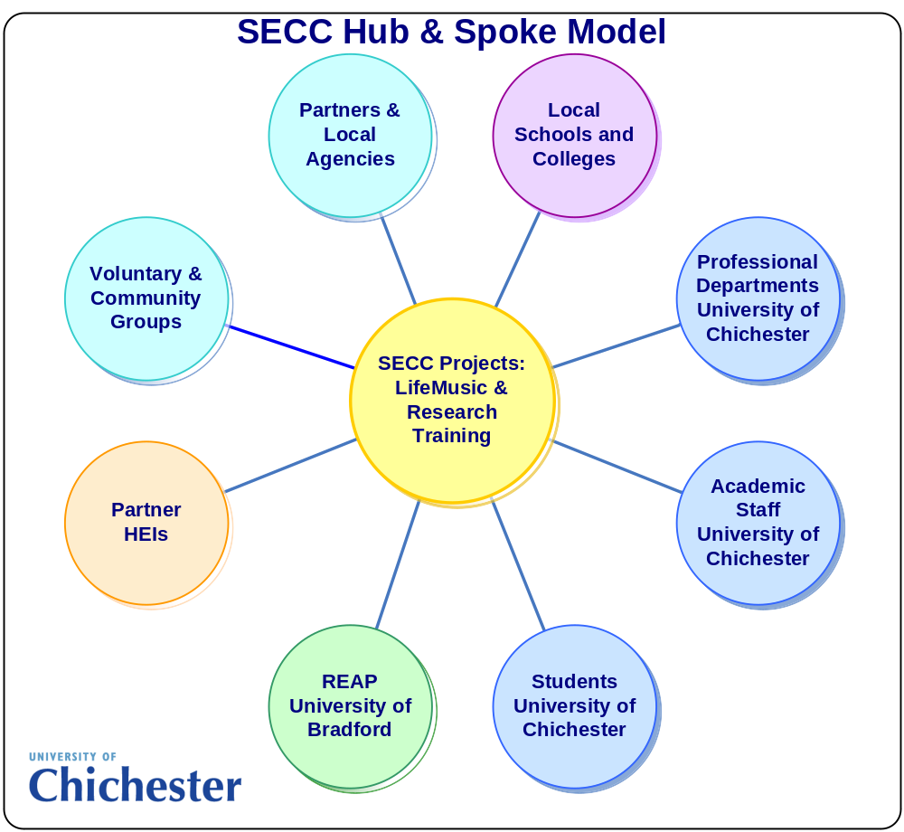 6
Working with voluntary and community groups will create a new culture within the University’s community relationships strategy, stimulating understanding and new attitudes towards Higher Education and greater respect by academics for what they can learn from the communities around them – enhancing social relationships, networks and trust as the University and Communities learn to exchange skills and knowledge for the benefit of all.

Chichester’s hub and spoke model of engagement would enable demand-side response to ‘community knowledge exchange and transfer’: in effect immediate access to the University’s intellectual capital whilst supporting communities’ requests to develop their own capacity to respond to their health and wellbeing needs. Our statutory and voluntary and community partners have committed in writing to personnel secondment, access to their databases, conduits to grass-roots community groups not normally affiliated to government agencies, knowledge support and co-ordination of links to appropriate community groups e.g. older people and migrant workers.

Major partners have committed to project management, administration, finance marketing, website management, sourcing and contracting of venues and workshop space with links to their “sister” projects previously and independently financed through other funders including Arts Council England.

The University of Chichester has sought an embedded approach to communication with the surrounding community by developing partnerships with established and recognised agencies – this has involved listening to community voice and recognising that HE often appears intimidating and impenetrable. To illustrate our new approach, our partnership with the Chichester and Arun CVS (Community Voluntary Sector) established registered charities who aim to combat social exclusion, disadvantage and inequalities in accessing local services by providing support that promotes, develops and strengthens action will be a major conduit connecting community and academia and is one example of our recognition of expertise successfully existing within the community.

There has been conscious effort by staff, Dr Clark and Dr Paton are exemplars, of individual action and activities linking to community research but the opportunity offered by this Higher Education Funding Council of England (HEFCE) funding will enable activity to establish direct community links rather than a response to academic interest, external agency approaches or a successful bid – we will be able to take action within the local community, empowering voluntary and community groups to develop their aspirations and wellbeing.

In order to meet Lord Dearing’s expectation that: “Higher Education needs to help individuals and society to understand and adapt to the implications of change, while maintaining the values which make for a civilised society” (http://www.ncl.ac.uk/ncihe/index.htm) the University of Chichester’s South East Coastal Development Manager will ensure collaboration, participation and ongoing links to HEFCE funded project activity, students, academics, local community groups and agencies through and with our Widening Participation, Life Long Learning, Volunteer Activities and Careers professional departments together with establishing further academic Faculty links by strengthening relationships with the Deputy Deans for External Relations and Research.

A new Research and Employer Engagement Office (REEO) is being implemented at the University of Chichester to support academic and professional staff to facilitate externally supported collaboration and research; enhancing and improving research grant administration. A Head of REEO has been appointed with direct responsibility to the new Pro Vice-Chancellor, External Relations, Research and Employer Engagement. The Head of REEO will work closely with the Deputy Deans for External Relations and Research to evolve the Research and Employer Engagement Strategy across the University. The creation of REEO builds on the legacies of Knowledge Exchange from the previous HEFCE Capability Fund and Higher Education Innovation Fund (HEIF) 3.

Research and Evaluation
Having been introduced to “The Ivory Tower and Beyond: The University of Bradford at the heart of its community” paper and their successful Reciprocity, Externalities, Access, Partnerships (REAP) approach to measuring community engagement by our SECC partners at the University of Brighton, the SECC team at the University of Chichester are delighted at the match in thinking of all the academics involved.

The REAP framework fits and sits neatly around the proposed projects approach and will enable consistent cross-county research assessment and development by unifying the unique approaches adopted by the three Sussex based Universities (Chichester, Sussex and Brighton) into a coherent research result beneficial to all stakeholders in the SECC programme and beyond.

This framework supports the University of Chichester notion that working directly within communities demonstrates HE approachability enabling the improvement and recognition of community engagement activity whilst enhancing and empowering community relationships and voice; the voluntary contributions of staff, students and partners facilitating this relationship. The three year SECC programme would contribute to greater self-confidence and mutual trust improving the ability to address local issues with perceived sincerity and rapidity.

The University of Chichester’s SECC team and those associated with the projects have agreed to keep a “Reflective Diary”, recording aspirations, facts and feedback; dividing the diaries between reflection at one end and fact at the other. This will enable assessment of participant experiences and will cross student, staff and project management and development experience.

A survey will be conducted at the beginning of the SECC programme and again at each new cohort introduction. Post-project experience assessment, feedback and surveyed evidence will be collated and analysed, and having encouraged and nurtured an understanding of the value of scholarship and critical thinking amongst socially deprived community groups, informed scholarship thinking would be one of the desired outcomes.

Built into the project objectives would be the individual contribution to a wider civic role for a strategic purpose – student, staff and community volunteering offers a valuable opportunity to gain work experience and share skills whilst incorporating links with the University’s Volunteer Activity and Careers Departments would ensure sustainability of the project work and aims. This outcome is essentially a commitment to work with, rather than deliver to, communities.

Success criteria
Community engagement requires a change in culture from all participants; critical thought processes becoming the norm in ‘deprived’ voluntary and community groups and an understanding that willpower and energy can determine positive outcomes from improbable beginnings for the academics and their Faculties. Voluntary and community groups may chose to be assisted by or work with funding co-ordination staff at the University of Chichester to submit bid applications for further project income but the real ‘value for money’ will come from the inclusive attitude to Higher Education that will develop throughout the three year programme from the community engagement activities.

Evaluation enabling measurement of perceived health and wellbeing improvement would be evidenced through case studies of the 'SECC effect' on individuals including before and after measures for self esteem, confidence in decision making etc.; analysis of surveys and the Reflective Diaries, and through incorporation of our projects into the REAP evaluation framework but other less-socially specific areas of evaluation would be evidenced:

- Exchange and development of good practice amongst voluntary and community groups, partners and the University of Chichester (both campuses)
- Willingness and scholastic ability of voluntary and community groups to ensure continuity of activities within the community
- Integration of voluntary and community groups onto University campuses and into campus life through good practice and event sharing
- Case studies of good community practise positively impacting cross-border activities
- Publicised and participatory ‘points of entry’ for third sector University communication
- Creation of new academic and community engagement products and events
- Publication of papers, books and articles – film, magazine, newspaper
- Range, roles and number of participating practitioners and partners
- Volume of events that involve public, practitioners, academics and students
- Increase in number of academics and students undertaking significant community-university engagement
- Changes in policy and procedures at the University of Chichester that develop, support and value community-university engagement
- Well attended and well received series of seminars and a project end conference where methods and good practices are discussed openly with the public 8
Evaluation approach
SECC project activities at the University of Chichester will be subject to continuous internal evaluation with documented evidence of the work by students, staff, partners, voluntary and community groups throughout the three-year programme lifecycle.

The University’s South East Coastal Communities Development Manager will be responsible for facilitation of the University and Community Group resources ensuring capture of agreed outcome measurements demonstrating the effectiveness and the impact of music and research training within the community exchange programme.

The Development Manager will ensure that detailed documentation of enlisted practitioners will be kept to explore the impact of the programme. The SECC team will capture the facilitators and inhibitors to effective community and university partnership processes. A qualitative approach will be used to explore all participants’ experiences, concerns and views of the University of Chichester SECC programme over the three years.

Author: Dianne Sherlock, South East Coastal Communities Development Manager Date: Monday 28 April 2008

9

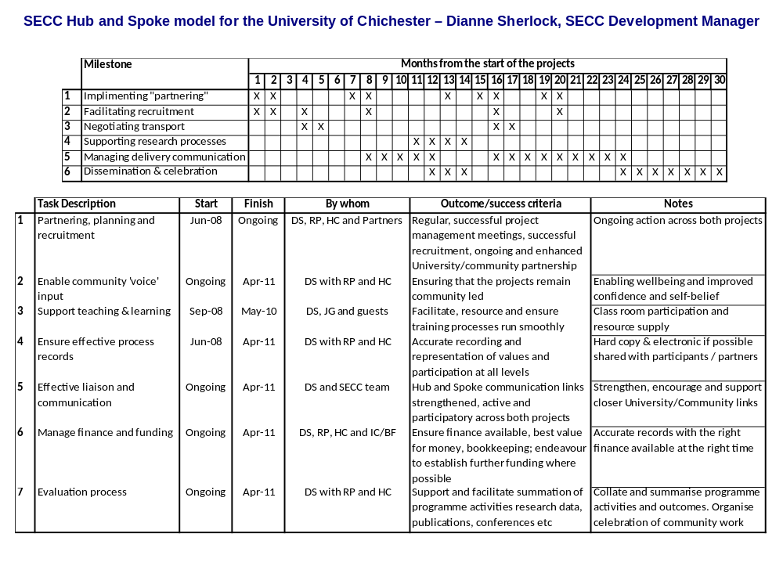
“A community is democratic only when the humblest and weakest person
can enjoy the highest civil, economic, and social rights
that the biggest and most powerful possess.”

A Philip Randolph
African-American civil rights leader
April 1889 – May 1979

The meaning of ‘community engagement’
As defined by HEFCE (November 2007) for the Beacons Project and in the context of this South East Coastal Communities project, ‘community engagement’ involves specialists in higher education listening to, developing their understanding of, and interacting with non-specialists. The ‘community’ includes individuals and groups who do not currently have a formal relationship with Higher Education Institutions through teaching, research or knowledge transfer.

Professor David Eastwood, Chief Executive of the Higher Education Funding Council for England, in Bridging the gap between higher education and the public paper (9 November 2007), is quoted as saying:

“Universities have never been more outward looking, or more aware of the wider responsibilities to engage across a range of issues. This initiative [Beacons] is timely as it will reinforce this increasing openness by recognising, rewarding and supporting public engagement across all higher education activities and building capacity to do so in all subjects.”

The SECC programme has enabled the University of Chichester to take on the established ethos of the Beacons initiative endorsing the National Co-ordination Centre for Public Engagement’s aims to listen and learn, offer leadership, create a community-participative working framework and to act as a gateway and point of contact.

With these aims in mind the South East Coastal Communities Development Manager has agreed with the University’s SECC Community Partners to use methods of engagement that are fit for purpose. The development and ongoing growth of the Hub and Spoke Model as a participative working framework was agreed to be the ideal driver for deeper and more purposeful communication throughout the county and into minority community groups.

Hub and Spoke relationships
As one of the University’s main communication partners, the Chichester & District Council for Voluntary Services, in response to the development of our Hub and Spoke relationship and communication processes has confirmed:

This model enables “cascading of information to voluntary / community groups, engaging groups through our existing networks and ties the projects in with our existing services (Volunteer Centre, Carers Liaison Project, Support to Voluntary and Community Groups).”
Kate Scales, Chief Officer

Application of the National Standards for Community Engagement, delivered by the Scottish Community Development Centre on behalf of Communities Scotland and endorsed by the Scottish Executive (Published 2005) would support our community partners’ delight in agreeing to participate in, and direct, the University of Chichester’s LifeMusic and Training Researchers projects.

Ten Community Engagement standard indicators
Involvement: we will identify and involve the people and organisations who have an interest in the focus of the engagement
Support: we will identify and overcome any barriers to involvement
Planning: we will gather evidence of the needs and available resources and use this evidence to agree the purpose, scope and timescale of the engagement and the actions to be taken
Methods: we will agree and use methods of engagement that are fit for purpose
Working Together: we will agree and use clear procedures that enable the participants to work with one another effectively and efficiently 11
Sharing Information: we will ensure that necessary information is communicated between the participants
Working with Others: we will work effectively with others with an interest in the engagement
Improvement: we will develop actively the skills, knowledge and confidence of all the participants
Feedback: we will feed back the results of the engagement to the wider community and agencies affected
Monitoring and Evaluation: we will monitor and evaluate whether the engagement achieves its purposes and meets the national standards for community engagement.

University of Chichester and Community Partners’ work ethic and approach
- All groups of people whose interests are affected by the issues that the engagement will address are represented
- Behave openly and honestly – there are no hidden agendas, but participants respect confidentiality
- Take decisions on the basis of agreed procedures and shared knowledge
- Information is accessible, clear, understandable and relevant, with key points summarised
- Within the limits of confidentiality, all participants have equal access to all information that is relevant to the engagement
- Learn from others and seek improvement practice
- Encourage effective community engagement as normal practice
- Each party identifies its own learning and development needs and together the participants regularly review their capacity to play their roles
- The competence and understanding of the engagement system as a whole is regularly evaluated by the participants as it develops
- Participants share their skills, experience and knowledge with community and agency colleagues
- Explanations about why decisions and actions have been taken are shared along with details of any future activity
- The engagement process and its effects are continually evaluated to measure progress, develop skills and refine practices
- The information is presented accurately and in a way that is easy to use
- The participants agree on the lessons to be drawn from the evidence of the results and changes that occurred
- The participants act on the lessons learned
- Progress is celebrated
- The results of the evaluation are fed back to the participants and the wider community
- Evidence of good practice is recorded and shared with other agencies and Communities

The ‘Voice’ of our Community Engagement Partners
When asked what would be lost if our partnerships within the SECC programme and the LifeMusic and Training Researchers projects did not go ahead, our community partners said:

Roots Around the World – Sue Ringwood:
“The project has great potential in creating new partners and developing a cultural exchange programme throughout West Sussex and across county boundaries. The project would also sow the seeds for a university international exchange programme.”

Care Training Consortium – Sue Craig:
“This project offers a superb opportunity rarely seen in the social care arena to not only train care staff alongside service users but to also extend the activities to a range of different service areas under a single project.”

Rox Music and Arts – Robin Parker, NRG Marketing:
“The SE Coastal Communities project will play a vital role in the development of the Rox Music & Arts Charity. Rox already provides subsidised music and arts workshops for young people aged 11-19 who come from areas of extreme social deprivation. This project has enabled us to build a new and strong relationship which has enabled us to 'fast-track' our business plan as negotiations are now well underway for the building of the new 'Rox Academy' on the University campus which will provide professional facilities for a much greater target audience; 'Special needs', 'Intergeneration’ and 'Migrant Groups' have already been discussed for future development.”

12
West Sussex County Council – Karen Howard:
“This project has a real future and the partnerships already established are very strong. If this collaboration was not to go ahead, a significant opportunity of integrating migrant workers / ethnic minorities and the local communities will be missed.”

West Sussex County Council Racist Incidents Team – Dan Sanders:
“It is an opportunity to begin work that can be proactive in addressing local and national misinformation in an enjoyable and productive manner. Without this project there are not many other opportunities for both young people and professionals to explore and tackle issues that have the possibility of leading to community tensions.”

Portsmouth Arts and Community Education (PACE) – Emma Wright:
“The potential benefits include increased confidence, increased participation in other services; opportunities to access information, advice and guidance on learning and training progression routes.
The outcome of these participants not being offered these opportunities can mean that they remain trapped in the cycle of substance misuse or do not find ways to address their housing issues or remain isolated from society.”

Imagine
Imagine if we delivered our promises together? We believe community engagement will help the people who live in south east coastal communities to be healthier, fitter and more able to cope with life. If we, the local Higher Education Institute, work with and help the community and voluntary sector to network, learn about funding and training opportunities, and demonstrate support by learning more about what they all do then this SECC Programme will doubtless be a sustainable community driven success.

Author: Dianne Sherlock, South East Coastal Communities Development Manager Date: Monday 28 April 2008

Bibliography

HEFCE – Bridging the gap between higher education and the public
9 November 2007
http://www.hefce.ac.uk/news/hefce/2007/beacons.asp

A. Philip Randolph quote
Voice of Community Engagement (VOCE)
http://www.hearyourvoice.org.uk/

The Ivory Tower and beyond: Bradford University at the heart of its communities
REAP approach to measuring its Community Engagement report
Professor Jennifer Pearce and Martin Pearson with Dr Sam Cameron

National Co-ordination Centre for Public Engagement
http://www.publicengagement.ac.uk/nccpe/default.htm

Scottish Community Development Centre
http://www.scdc.org.uk 13

LifeMusic Method

Dr Rod Paton
Senior Music Lecturer Community Music

14
Dr Rod Paton

Knowledge Exchange

Summary: LifeMusic Method

Activity
The University of Chichester through its Music Department has a long record in the development of research and training in community music. The LifeMusic method has been developed through ongoing community music workshops and the establishment of two final year modules in community music, one of which involves outreach project work. The SECC project would enable the health and wellbeing benefits of this learning to be extended to external communities, including migrant workers, older people working alongside young people and people working in companies.

The LifeMusic Method is designed to enhance wellbeing and to promote healthy relationships within groups and has been successfully developed in a variety of community settings over many years. The Method would involve direct participation (based on group improvisation) in music-making using frameworks which are accessible to all and simple to learn but highly effective in outcomes.

Three major initiatives are to be developed for the funding period, in collaboration with Roots Around the World West Sussex, and numerous representative organisations from the University of Chichester’s community partnerships. These will be based around 1) work targeting the migrant workers’ community on the South Coast in partnership with Roots Around the World; 2) intergenerational work in partnership with Age Concern, the University’s SECC Research for Older People project and local community colleges/high schools; 3) Sound Company – a well being in the work place project in collaboration with local business and community partners.

Feedback from University partners already hints at an extension of the LifeMusic Method experience into joint activities and presentations with Performing Arts, Dance, Fine Art and Media Production. The aim is to create a rounded educational and life enhancing personal experience towards the wellbeing and general confidence of community participants.

Music students choosing to study the “Music and the Community: Outreach” module will be encouraged to work with the University’s Community Engagement Partners to develop LifeMusic Methodologies within their groups through discussion and feedback from clients. Furthermore, it is planned to establish Community Music as a designated minor strand in the BA (Hons) music programme from 2010.

Background
Dr Rod Paton, the originator of the LifeMusic Method, is a musician who has been working with groups of all kinds for over twenty-five years. He has worked as a composer, arranger, jazz musician, teacher and has also trained professionally in music therapy. In 2000 he published a book of workshop and improvisation guidelines for teachers and community musicians, Living Music; this book is shortly to be updated, extended and republished.

The LifeMusic Method reflects a perceptible shift in public attitudes towards the functions of music: a shift away from the monopoly of composers and recording companies and towards autonomy, participation and social inclusion. Music is increasingly being understood as a medium for self growth, healing and social bonding. Being part of an improvising group can increase self esteem, build confidence, relieve stress and integrate body, mind and spirit. Making music, being a creator rather than a consumer, is a birthright, a natural and organic element of life; reclaiming this birthright is what LifeMusic is about.

How the proposed activity addresses health and wellbeing and rationale for prioritising it:
There will be three specific proposals within the SECC/LifeMusic initiative: 1) intergenerational work with Age Concern/Help the Aged; 2) development of a migrant based band in collaboration with Roots Around the World; 3) Sound Company – the development and research of the benefits of LifeMusic within the workplace. 15
Philosophy of the Programme
- The LifeMusic Method is based on the principle that everyone is capable of creating music
- LifeMusic uses participatory and experiential music as a means to enhance wellbeing and promote healthy relationships
- LifeMusic therefore has the potential to strengthen and increase community awareness.
- LifeMusic is both an attitude and a method. The attitude is non-judgmental, therapeutic (in the broad sense) and participatory
- The method is based on long-term empirical and theoretical research into music improvisation as a creative community tool.
It is proposed to set up training opportunities for any South Coast musicians who wish to be involved with the project and who demonstrate sufficient musical skills and communicative potential to run their own workshops.

How the proposed activity builds on previous work in the area locally: Aims of the programme
The LifeMusic philosophy and approach to community music is well established in the immediate region and beyond. Local workshops have been running in a variety of community contexts and venues since 1989 and client groups include: adults and children with a learning disability (e.g. Fordwater School, the Wrenford Centre); teachers; therapists and counsellors; teams in corporate environments (e.g. T-mobile); self-referring groups (in UK, Norway, Germany and Czech Republic).
The aims of the LifeMusic proposal cluster under three project headings:
- Migrant Exchange:
- In partnership with Roots Around the World to promote musical interaction between a variety of communities
- To use the LifeMusic platform to promote cultural understanding, exchange of knowledge and skill and challenge perceptions through musical integration.
- Intergenerational:
- In partnership with Help the Aged to provide training and delivery of LifeMusic with young people working alongside older people
- To promote wellbeing and social interaction between the two groups
- To provide a research platform, which will investigate and evaluate the benefits, musical, social, physical and emotional of this approach.
- Sound Company:
- To develop the use of music to enhance wellbeing in the workplace
- To evaluate the benefits of the LifeMusic approach for people working in corporate environments.
Options Appraisal
The proposal provides for a direct means whereby the LifeMusic methodology can be applied to the three community areas. Other less direct options exist (e.g. undergraduate training and already established though isolated community music activities). Parallel projects also apply to wellbeing (e.g. through sport related activity or dance and movement). LifeMusic is the only proposal which aims to apply participatory music in a manner which combines training, delivery and research as well as the drawing together of expertise and the development of a network of practitioners.

Risk Identification and Management
Each of the proposed projects is dependent on the commitment of partners:
- The intergenerational proposal is being developed initially with Help the Aged and Littlehampton Community College. In the event of either of these withdrawing, the cooperation of other organisations (e.g. Mencap) and other colleges would be relatively easy to develop.
- ‘Roots’ is well-established in the region and fully involved in planning. The University is already involved in two current ‘Roots’ projects and working relationships are well established.
- The substantial number of local businesses, large and small, provides a significant reservoir of potential partners for Sound Company.
- Training in LifeMusic methodology and human resource development is intrinsic to the project design and delivery. This will provide a growing resource of practitioners in developing and maintaining the momentum of the projects.
16
Sustainability:
There will be sustainable benefits as the community groups involved in the Method will continue to work within their own community bases, the University, other local voluntary and community groups and statutory organisations, thereby sustaining health and wellbeing.

How the proposed activity will be mutually beneficial and will use University resources:
The establishment of regular (weekly) workshops is seen as an essential feature of the initiative. Weekly community workshops will be run in a central venue in Bognor Regis (e.g. the University of Chichester campus or Hotham Arts Centre). These workshops will be set up with client groups located through one or more of the partners who have already expressed an interest in the Coastal Communities initiative.

The workshops will use the LifeMusic Method to engage participants in group improvisation. The method provides ample space for participants to bring to the gatherings their own musical experiences – their own songs and styles – and creates a means whereby this potentially disparate material can be simultaneously accepted, acknowledged and transformed in creative collaborations.

Anticipated outputs:
Objectives of the programme
The major initiative for this period, in collaboration with Roots Around the World West Sussex, University of Chichester and numerous representative organisations from the South Coast, is based upon a developing series of community projects which are primarily but not exclusively aimed at the growing migrant community along the South Coast of England.

Projected future developments
- Music participants will compose and record a collaborative piece of music inspired by the music and cutural background of the focused Artist/Band
- Dance participants will explore movement and dance inspired by the focused artists and choreograph a piece/s to accompany the music participants newly composed work
- Video Art participants will create work following their in-depth research into the cultural, social, historical, geographical and political background of the focused Artists
- All the Music, Dance and Video Art participants having the opportunity to perform or present their work at public performances by the featured world music artists
- Introduce community groups to a range of arts activities; the leadership training and mentoring programme will take their skills further, which in turn will encourage more groups to take part in the activities.

LifeMusic with their main partner Roots Around the World, incorporating all other interested partners, would wish to celebrate and develop a better understanding of global cultural diversity, offer leadership training, mentoring and professional development.

They aim to develop strong partnerships and collaboration between coastal community schools, colleges, universities, arts organisations, venues, practitioners and the community, whilst creating awareness and addressing racial issues in our county and surrounding areas.

Suggested evaluation approach:

Training outline
The LifeMusic training is already well established amongst undergraduate students at the University where it provides a final year option for students wishing to develop their musical skills with a view to establishing themselves as community musicians after graduation.

It is proposed to set up further training opportunities for any South Coast musicians who wish to be involved with the project and who demonstrate sufficient musical skills and communicative potential to run their own workshops. A ten week basic skills course (30 hours) will be followed up by a further ten weeks (30 hours) of outreach training leading to the award of a Certificate of Community Music Proficiency. The Certification will be based upon the Sound Sense/Music Leader Code of Practice for Community Musicians and accreditation will be sought from an appropriate body.

17
Research
An integral aspect of LifeMusic is the underpinning of the practice with academic and theoretical outcomes in the form of evaluative reports, conference papers and research articles. Dr. Rod Paton has recently been appointed to the editorial board of the International Journal of Community Music and invited to contribute a chapter to a book to be published early next year by Intellect Books. He is also currently the chief evaluator for the two-year ‘Dialog’ project being run by Roots Around the World. Other LifeMusic trainees and students will be encouraged to contribute to a research base. It is intended that the SECC funded projects will provide considerable research outcomes and therefore help in the establishment of a community music research culture within University of Chichester and the local region.

Having been introduced to the University of Bradford’s REAP approach to measuring community engagement by our SECC partners at the University of Brighton, the SECC team at the University of Chichester are delighted at the match in thinking of all the academics involved.

The REAP framework fits and sits neatly around the proposed LifeMusic Method and will enable consistent cross-county research assessment and development by unifying the unique approaches adopted by the three Universities into a coherent research result beneficial to all stakeholders in the SECC programme.

Author: Dr Rod Paton, Senior Music Lecturer – Community Music Date: Monday 28 April 2008
18
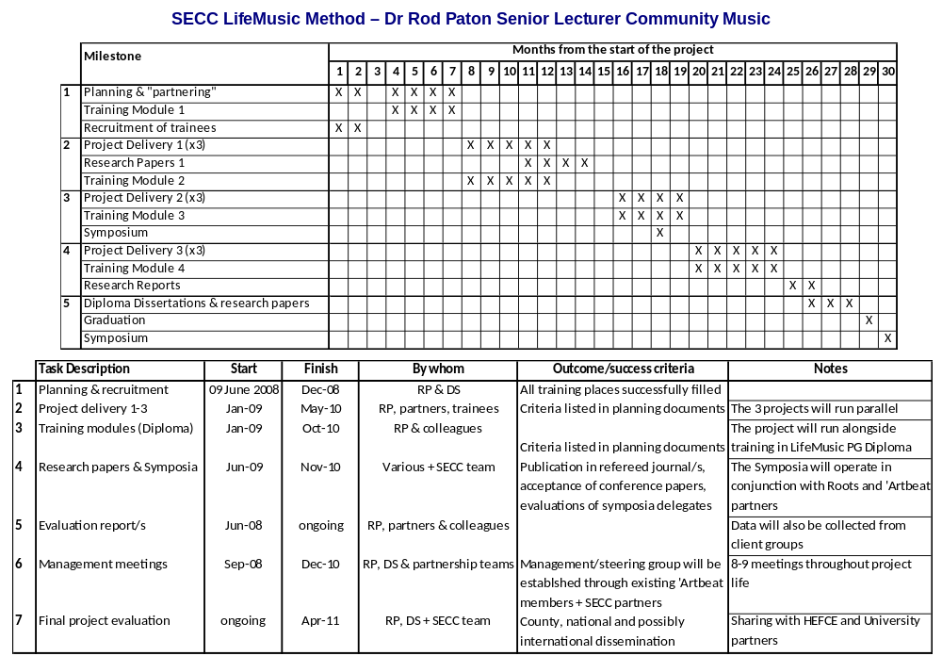19
SECC BUDGET

LifeMusic Method: Dr Rod Paton

The total SECC programme funding amount allocated by HEFCE to the University of Chichester is £175,000 in total over the two year period from June 2008 through until May 2010, this equates to £87,500 per annum or £43,750 per project per year.

The annual allocation of £43,750 for the LifeMusic project fulfils the direct and additional overheads across the two year phase of the LifeMusic project. From project initiation incorporating community partners’ in kind contributions will ensure that the project thrives within the community and enables sustainability without recourse to immediate cessation of activity with the project-end removal of academic input or direct reliance on additional HEFCE funding.

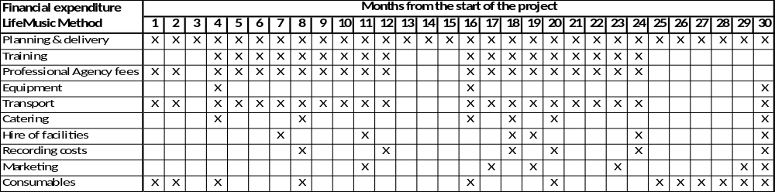

With the major Community Partner contributions surpassing the HEFCE financial contribution, the ongoing life and activities of the project are sustainable in the longer term. Furthermore the University of Chichester will guarantee sufficient funding to ensure the success of both projects and that the SECC Development Manager is not dependent on financial constraints.

Partnerships are likely to positively impact the forecast additional costs associated with marketing and consumables due to an existing local ‘unwritten agreement’ to share databases, designers, printing costs etc with much talent being used and production taking place internally rather than often more costly outsourcing.

The SECC Development Manager has secured a total of 44 partners, with further support being proffered as understanding of the projects develops, to both SECC projects and it is therefore possible to work with and call upon greater resources than those detailed above.

Signature of Director of Finance, or authorised deputy from sponsoring institution:

Signature: . . . . . . . Ian Child . . . . . . . . . . . . . . . . . . . . . . . . . .

Name: Ian Child
Role: Chief Financial Officer for the University of Chichester

Date: Monday 12 May 2008

20

Training Older People as Researchers

Dr Heather Clark
Reader in Social Gerontology

21
Dr Heather Clark

Knowledge Exchange

Summary: Training older people as researchers

Activity
The University of Chichester is engaging with the local community and is represented across a range of organisations and agencies, including those comprised of, working for and/or with, older people. West Sussex has a significantly ageing population. In some areas of the county, older people comprise around one quarter of the whole population. This contrasts with the young age profile of rural economic migrants and indigenous 17-24 year olds identified by Widening Participation at the University of Chichester.

Existing work within the University of Chichester includes the involvement of older people, as service users as carers, within the development and delivery of programmes such as social work, while the health and wellbeing of older people is a central feature of research activity and community engagement across a number of University Schools. Increasingly, the University of Chichester is taking the benefits of “excellent teaching and research directly into the economic, cultural, community and civic life of nation” (HEFCE’s Strategic Plan 2006-11, p.36, s125) thereby contributing to social inclusion and community wellbeing while drawing upon learning about social and community needs in the development of “agendas for research and teaching” and creating “vibrant communities of practice” (ibid.).

Background
Dr Heather Clark, Reader in Social Gerontology, has extensive experience of research with and involving older people and is the lead author of Going home: Older people leaving hospital; ‘That bit of Help’: The high value of low level preventative services for older people; Piloting choice and control for older people; and ‘It pays dividends’: Direct payments and older people and was co-editor of Evidence submitted to the Older People’s Inquiry into ‘That Bit of Help’ and of the report of the Older People’s Inquiry into ‘That Bit of Help’.

Heather was also lead author of the following chapters in the Evidence volume: ‘What’s happening? Demography, service patterns and experiences’; ‘Addressing what older people want? Research review’ and ‘Addressing what older people want: Policy Context’. She was a member of the secretariat team to the Older People’s Inquiry into ‘That bit of Help’ established by the Joseph Rowntree Foundation and remains research active and is currently in negotiation with potential funders for future research.

The ageing of the population is posing a challenge to policy makers and those delivering services at national and local levels. In response, the current direction of government policy is underpinned by the twin philosophies of, on the one hand, prevention of ill-health and loss of function, and on the other, promotion of wellbeing and social engagement.

The perception of older people as dependent, passive recipients of welfare services is now shifting to one where they are recognised as active agents and contributors to community wellbeing and to the local and national economy. Accordingly, a raft of recent government Green and White policy papers and strategy documents has stressed the importance of facilitating older people’s access to facilities and resources to promote active and healthy ageing. Opportunity Age (HM Government, 2005) has, to that end, included access to education as one of the Quality of Life indicators.

Nevertheless, it is important to remember that advanced ageing can also be a time of loss, increasing need for support and for some older people, problems of isolation.

The challenge posed by the ageing of society is a national, and indeed, global issue. In coastal towns, however, and as the Communities and Local Government Committee’s 2007 report: Coastal Towns
22
makes clear, extra demands are generated by the trend of outward migration of younger people and inward migration of older people. Additionally, social cohesion is compromised through tension between older and young people.
As part of its modernisation agenda, and linked to the agendas for social inclusion and social justice, the Government has placed various powers and duties upon local authorities through the Local Government Acts of 1999 and 2000 to address what many older people (and others) perceive as a ‘democratic deficit’. By this is meant that older people increasingly want a greater and more meaningful say in service planning and delivery in areas that affect their lives.

How the proposed activity addresses health and wellbeing and rationale for prioritising it:
Philosophy of the Programme
- The programme is underpinned by the concept of life long learning through enabling and supporting older people to develop research skills
- Older people will be providing a service to other older people through implementing approaches that effectively consult and engage
- Older people will be empowered by their involvement either as researchers or participants whose views will be sought on the development and evaluation of service delivery.

How the proposed activity builds on previous work in this area locally:
Aims of the programme
- To provide opportunities for older people to access a higher education environment
- To support the development of a dynamic cohort of adult learners with the attendant benefits of social interaction and intellectual activity that will enhance self-esteem and wellbeing
- To provide high quality and relevant research to support the development and commissioning of services that meet the needs, preferences and aspirations of older people
- To provide opportunities for older people and the University of Chichester research community to work collaboratively in planning and undertaking research activities involving older people.

Options appraisal (including what is lost by doing nothing):
The establishment of a fully funded and sustainable project will result in the benefits outlined in the project proposal. The emphasis is upon health and wellbeing, for the participants through social interaction and enhanced self-esteem, and, for the wider population, through the development of networks of support and more cohesive communities.

The project would provide invaluable links between the university and the older community. The option to do nothing would therefore result in the loss of significant potential benefits.

Risk – identification and management:
Risk 1: changes of personnel in community partners
Managed by: a robust framework of organisational commitment
Risk 2: potential occasional loss of confidence and commitment on part of older participants
Managed by flexible approach to learning and teaching; adaptation of materials according to learners’ needs; ongoing evaluation and review of progress; making learning fun.

Sustainability:
There will be sustainable benefits as the older people involved in the project will continue to work with the research community within the University of Chichester, with local community groups and statutory organisations, and with other older people within their communities, thereby sustaining health and wellbeing.

How the proposed activity will be mutually beneficial and will use University resources:
All University of Chichester staff are actively encouraged to share resources where and when possible, with their project partners, the local community and business colleagues.

Knowledge Exchange remit at the University of Chichester is to encourage an “outward looking” attitude enabling development of strong partnerships built on trust and strength of belief in advancing social, health and wellbeing activities to the population of West Sussex and Hampshire environs. This fact is evidenced by the commitment to the University of Chichester’s work of our singed-up partners.
23
The University will contribute venues for meetings, support for the Community Engagement programmes through Knowledge Exchange and its Healthy Living Working Group, as an extension to the hub and spoke route with community membership steering group decreed by our partners as the most effective form of communication for the community voice.

Anticipated outputs:
Objectives of the programme
- To invite older people to access a research skills training programme delivered by University of Chichester staff. The learning strategy will be developed in consultation with them.
- To promote the sustainability and effectiveness of ‘third sector’ organisations through
i. provision of training to older people who are members of or who are served by third sector organisations;
- collaborative working between the University of Chichester and the third sector involving the transfer of knowledge and skill and access to intellectual capital and academic resources of the University
- To provide a resource in collaboration with and for Local Authority, National Health Service, private and voluntary sector partner agencies to inform and evaluate service development for older people from the perspective of older people
- To assist statutory and voluntary agencies in identifying what older people want vis-à-vis their provision of services and facilities
- To assist agencies in identifying gaps in provision for older people and difficulties of access to mainstream provision
- To ensure that appropriate ethical/research governance is sought and approved through University of Chichester’s Ethics Committee processes for all research undertaken by older participants under the auspices/with the collaboration of the University
- To recognise and value the diverse experiences of older people through the opportunity for people from different ethnic and cultural backgrounds, disabled older people, older lesbians and gay men to have a “voice” in terms of how research should effectively be conducted, and the seeking of the views of all older people
- To actively promote social inclusion and develop networks of support between older people, and opportunities to access policy and decision makers in their communities thereby enhancing the development of supportive and cohesive communities
- To develop methods to support intergenerational engagement through providing links between older people, children, young people, and working age adults.

Projected future developments
Employing existing links, the University of Chichester will seek to extend the social research training programme to disabled people of working age.

Following the recommendations of the recent Comic Relief and Department of Health report (2007) into the prevalence of elder abuse, the University of Chichester would seek to offer training to older people to provide post abuse peer support.

‘Training older people as researchers’ and the project’s many interested partners, would wish to celebrate and develop a better understanding of global cultural diversity, offer leadership training, mentoring and professional development.

Suggested evaluation approach:
Training outline
The approach is practical and participatory with an emphasis upon skills development delivered in a way to build the confidence and self-esteem of participants. In that spirit, older participants will be involved in the design of the programme.

Training aims

- To provide a basic introduction to social research
- To provide training in planning, conducting and analysing a research interview
- To provide training in research ethics and research governance
- To develop skills of self reflection
24
Evaluation
Evaluation of the student experience of learning and teaching lies at the heart of Chichester’s commitment to providing a university experience which is of high quality.

A range of evaluation methods will be designed to generate data that can be used to inform enhancement of student experience and development of staff delivering the course. The course will be subject to ongoing evaluation through providing participants with opportunities to make reflective and anonymous feedback and suggestions.

Older participants will also be asked to complete a Reflective Learning Diary during the course of their study; this will be used to facilitate ongoing assessment as well as evaluation of their learning and training.

The framework of Bradford University’s REAP approach will be adapted to evaluate the wider impact of the course in terms of its contribution to Community Engagement. The REAP framework fits and sits neatly around the proposed project thinking and will enable consistent cross-county research assessment and development by unifying the unique approaches adopted by the three Universities into a coherent research result beneficial to all stakeholders in the SECC programme.

Author: Dr Heather Clark, Reader in Social Gerontology, School of Social Studies Date: Monday 28 April 2008
25
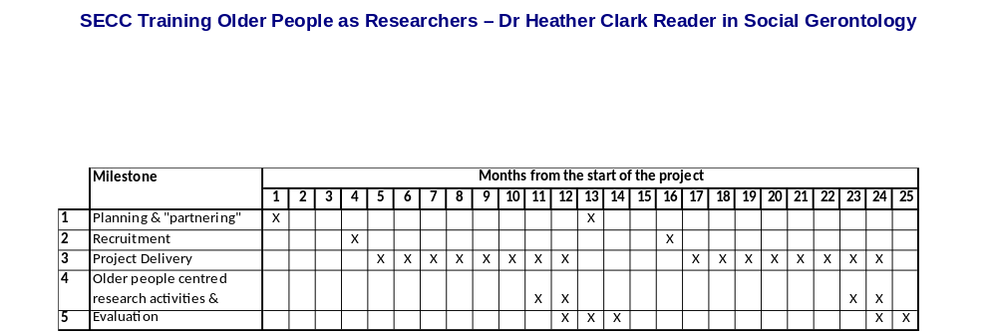
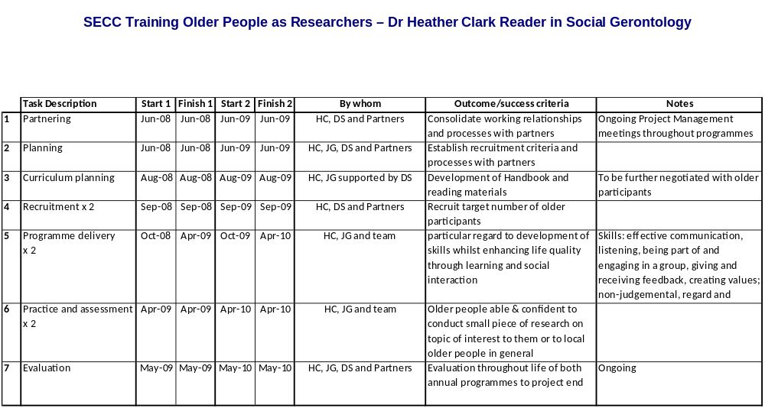

27

SECC BUDGET

Training Older People to be Researchers: Dr Heather Clark

The amount allocated by HEFCE to the University of Chichester is £175,000 in total over the two year period from June 2008 through until May 2010, this equates to £87,500 per annum or £43,750 per project per year.

The annual allocation of £43,750 for the Research project does not fulfil the projected direct and additional overheads over the two year phase of the project. From project initiation incorporating community partners’ in kind contributions will ensure that the project thrives within the community and enables sustainability without recourse to immediate cessation of activity with the project-end removal of academic input or direct reliance on additional HEFCE funding.

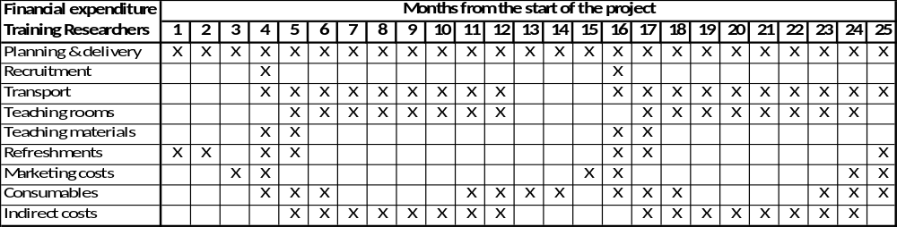

With the major Community Partner contributions surpassing the HEFCE financial deficit, the ongoing life and activities of the project are sustainable in the longer term. Furthermore the University of Chichester will guarantee sufficient funding to ensure the success of both projects and that the SECC Development Manager is not dependent on financial constraints.

Partnerships are likely to positively impact the forecast additional costs associated with marketing, consumables and indirect costs due to an existing local ‘unwritten agreement’ to share databases, designers, printing costs etc with much talent being used and production taking place internally rather than often more costly outsourcing.

The SECC Development Manager has secured a total of 44 partners across both projects, with further support being proffered as understanding of the projects develops, and it is therefore possible to work with and call upon greater resources than those detailed above.

Signature of Director of Finance, or authorised deputy from sponsoring institution:

Signature: . . . . . . . . Ian Child. . . . . . . . . . . . . . . . . . . . . . . . .

Name: Ian Child
Role: Chief Financial Officer for the University of Chichester

Date: Monday 12 May 2008

28
NOTES

